7.1 Communicating with the Power Analyzer
For RS-232C setting, refer to section 4.3.
To request data from the power analyzer, send a character to the POWER ANALYZER through PC's RS-232 port. Any character can be sent except the reserved characters (9, 4, 2, 1, G, N, R, W, U, S, T, X, EEE).
It is recommended that user send a SPACE character to the power analyzer (The ASCII code of SPACE key is 20 in hex). As having received a character (except the reserved characters) from PC, power analyzer will sent out 20 bytes to PC. The 20 bytes of data are divided into 4 groups, and each group has 5 bytes. Each group represents data for Watt, A, V, and PF.
If only one of the W, A, V, or PF is needed, user can send F1(W), F2(PF), F3(V), F4(A), or F5(Hz) for the data desired.

7.2 Decoding the 5 Data Bytes
Each byte of the 5 data bytes contains specific information and used for specific purpose. The information contained in the 5 data bytes is as following:

1st byte : 02 (Leading byte).
2nd byte: xx (Function and Range).
3rd byte : xx (Polarity and Digital Reading).
4th byte : xx (Digital Reading and Decimal Point).
5th byte : 03 (Ending byte).

1st and 5th Byte
The first byte and the fifth byte are fixed numbers of 02 and 03. They can be used as check bytes. If they are not 02 and 03, then probably there is a hardware problem either with PC or the power analyzer. It is also possible that the baud rates of PC and the power analyzer mismatch.

2nd Byte
The second byte contains the information of the function and the range. To find out the corresponding function and range, refer to the following table.

HEX | Decimal | FUNCTION/RANGE
03 | 3 | 200.0V
04 | 4 | 1000V
05 | 5 | Hz
31 | 49 | 2.000A
21 | 33 | 20.00A
C0 | 192 | 200.0W
C1 | 193 | 2000W
D0 | 208 | PF
FF | 255 | HOLD

[ Function Code Table]

3rd and 4th Bytes
The format of the 3rd and 4th bytes is as following.

4th byte 3rd byte
Bit No 15 14 13 12 11 10 9 8 7 6 5 4 3 2 1 0

Bit 0 Polarity (1: +,0: -) except in measuring Hz.
0: KHz, 1: MHz in frequency measurement.
Bit 1 Most Significant Digit.(0 - 1)
Bit 2 - 5 The second digit 0 - 9(0000 - 1001)
Bit 6 - 9 The third digit 0 - 9(0000 - 1001)
Bit 10 - 13 Least Significant Digit 0 - 9(0000 - 1001)
Bit 14 - 15 Decimal point position.

Bit 14 Bit 15
0 0 None (0000)
0 1 Right most position (000.0)
1 0 Next position (00.00)
1 1 Left most position (0.000)

Note1: Programmers watch for the bit order, it is reversely interpreted.
Note2: If you reverse the bit order after data is received, you can see that the data is actually BCD coded. It is actually easier to decode the data this way.

7.3 Example: Data 02 C0 21 B1 03 (in Hex)

Byte 1 : 02
Byte 2 : C0
Byte 3 : 21
Byte 4 : B1
Byte 5 : 03

Byte 1 and 5 are 02 and 03.
They are the right leading and ending bytes. The connection is O.K. and the data is valid.

Byte 2 is C0.
Referring to table 1, it is the function/range of 200.0 W.

Byte 3 and 4 are 21 and B1

Byte 4 Byte 3
Bit No 15 14 13 12 11 10 9 8 7 6 5 4 3 2 1 0
Binary 1 0 1 1 0 0 0 1 0 0 1 0 0 0 0 1
Hex B 1 2 1

Bit 0 1, positive value
Bit 1 0, the most significant digit is 0
Bit 2 - 5 0001, the second digit is 1
Bit 6 - 9 0010, the third digit is 2
Bit 10-13 0011, the least significant digit is 3
Bit 14 - 15 01, decimal is at the right most position (000.0)

The reading is +12.3 W

7.4 Changing the Baud Rate
To change the baud rate, send the ASCII code of 9,4,2 or 1 to change from the current baud rate to the desired baud rate. Be sure to change PC's RS-232 baud rate accordingly

9 : 9600
4 : 4800
2 : 2400
1 : 1200

7.5 Special Codes of Byte 3
When the power analyzer is in initial starting state, positive overload state or negative overload state. It sends out special code embedded in byte 3 (Refer to following table).

 | Bit 7 | Bit 6 | Bit 5 | Bit 4 | Bit 3 | Bit 2 | Bit 1 | Bit 0
Initial State | x | x | 1 | 1 | 1 | 1 | 1 | 1
Positive Overload | x | x | 0 | 0 | 1 | 1 | 1 | 1
Negative Overload | x | x | 0 | 0 | 1 | 1 | 1 | 0

x: don't care
[Special Code Table ]

7.6 Reserved Characters
The characters of G, N, EEE, R, U, W, S, T, and X are reserved . They are used as commands to power analyzer or datalogger (WM-02). 9, 4, 2, and 1 are used to change the baud rate.

7.7 Commands for Power Analyzer

Command | Function
Any character (except reserved characters) | Request for W, PF, V, A
F1 (ASCII code 241) | Request for W
F2 (ASCII code 242) | Request for PF
F3 (ASCII code 243) | Request for V
F4 (ASCII code 244) | Request for A
F5 (ASCII code 245) | Request for Hz
9 (ASCII code 57) | Change the baud rate to 9600
4 (ASCII code 52) | Change the baud rate to 4800
2 (ASCII code 50) | Change the baud rate to 2400
1 (ASCII code 49) | Change the baud rate to 1200
X (ASCII code 88, case sensitive) | Inquire the status of the power analyzer

X: Inquire the status of the data logger
Command string = "X"
Response: power analyzer sends out status byte
Return data string: 02 STATUS 03
Status Bit Map:
Bit7: 1: power analyzer busy, 0: ready

7.8 Commands for Datalogger(WM-02)
Commands are case sensitive.
Cmd | Mnemonic | Format
R | Read | R[1 byte] Address [2 bytes]
W | Write | W[1 byte] Address[2 bytes] Data[1 byte]
U | Read All | U[1 byte]
S | Start Recording | S[1 byte]
T | Terminate Recording | T[1 byte]
EEE | Erase Memory | EEE[3 bytes]
X | Inquire Status | X[1 byte]

Whole command has to be sent to DATALOGGER in 0.4 second, otherwise, command becomes invalid.

R ADDRESS: read one byte data at address ADDRESS from data logger.
ADDRESS: from 0 to 8191, the first byte is the low byte and the second byte is the high byte.
Example: Read the data at address 720
720 = 2*256+208
= 02(hex, first/high byte) D0 (hex, second/low byte)
= 2(decimal, high byte) 208(decimal, low byte)

Command string = "R" + CHR$(208) + CHR$(2)
Response: data logger send out the data stored at address ADDRESS with the leading and ending byte 02 and 03.
Return data string: 02 DATA 03.

W ADDRESS DATA: write one byte data DATA to address ADDRESS.

ADDRESS: from 0 to 8191, the first byte is the low byte and the second byte is the high byte.
Example: Write 150 to address 981
981 = 3*256+213
= 03(hex, first/high byte) D5 (hex, second/low byte)
= 3(decimal, high byte) 213(decimal, low byte)

Command string = "W" + CHR$(213) + CHR$(3)+CHR$(150)
Response: data logger write the data to the specified address.
Return data string: None.

U: read all the data stored in the memory from 0 to 8191.
Command string = "U"
Response: data logger sends out all the data in bytes with leading and ending byte 02 and 03
Return data string: 02 byte0 byte1 ... byte8190 byte8191 03

S: command data logger to start recording (equivalent to pushing RECORD
button on the front panel of data logger)
Command string = "S"
Response: data logger start recording
Return data string: None

T: command data logger to terminate recording (equivalent to pushing the RECORD button again on the front panel of data logger)
Command string = "T"
Response: data logger terminate recording
Return data string: None

EEE: reset the data logger (equivalent to pressing the RECORD and POWER button).
Command string = "EEE"
Response: data logger clear memory
Return data string: None

X: inquire the status of the data logger
Command string = "X"
Response: datalogger send out status byte
Return data string: 02 STATUS 03
Status Bit Map:
Bit0: 1: recording, 0:idle
Bit4: 1: datalogger or memory locked, 0:data logger and memory OK
Bit5: 1: datalogger is self-testing, 0: not self-testing
Bit6: 1: part of the data logger memory is locked, 0:OK
Bit7: 1: power analyzer/data logger busy, 0: ready

7.9 Memory Map for Datalogger (WM-02)

Address | Contents
0-1 | Memory Write Counts (Increment if reset and record)
2-3 | ID (Identification number for each meter, user can enter his/her own ID)
4 | Firmware version
5 | Recording Mode  1: max mode: record the maximum value measured during the sampling interval  2: min mode: record the minimum value measured during the sampling interval  Others: normal: record the value measured at the end of sampling interval
6 | Memory K size = value / 4 (eg. 4 = 1K).
7 | Reserved
8-17 | Date and Time MM DD HH MM SS (10 bytes). Used as memo to user.
18-19 | datalogging Sampling time in counts, 1 count = 0.4 second
20-21 | Last record address if user press record button to stop recording
23-24 | Reserved
40 | Memory status, 1: record full, 0: not full
41-42 | Counts of memory write failure, 0 when reset
43-44 | Last write failure memory address, 0 when reset
45 | Self-test enable byte when power on and as self-test result byte.  150(96 in hex): enable, others: disable  Result: 1: pass, 2: fail, 0: when reset
46-47 | First memory write failure address encountered
48 | Power-on baud rate, 1: 1200, 2:2400, 4:4800, others: 9600
57-58 | Frequency in KHz
59 | ASCII output mode: 1: Continuous Mode, 2: One Shot Mode, others: Disabled
60-61 | Continuous ASCII Output Interval to RS-232C port in counts,  1 count = 0.4 seconds
61-95 | Reserved
96-8191 | Data area, stored in W, A, V, PF order. 8 bytes/record.  Record 1 = Address 96 - 103

VIII. AC Adaptor and Replacement of Batteries and 20A Fuse
8.1 Using AC Adaptor
When using AC adaptor, make sure the output is 12VDC, and make sure the polarity is the same as indicated on the front panel.
8.2 Battery Replacement
When the low battery symbol is displayed on any of the LCDs, replace the old batteries with 8 1.5V AA batteries.
1. Turn off the power analyzer.
2. Open the battery compartment by using a screw driver
3. Replace the old batteries with new batteries
4. Replace the battery compartment.

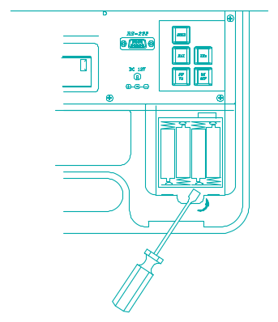

8.3 20A Fuse Replacement
Remove the 20A fuse cover as indicated in (5) in section II. Check if fuse is blown. If yes, replace it with a new 20A fuse.

Warning: Do not replace the blown fuse with any fuse greater than 20A.

IX. Measurement of 3-Phase 3-Wire Power
9.1 Using One Power Analyzer
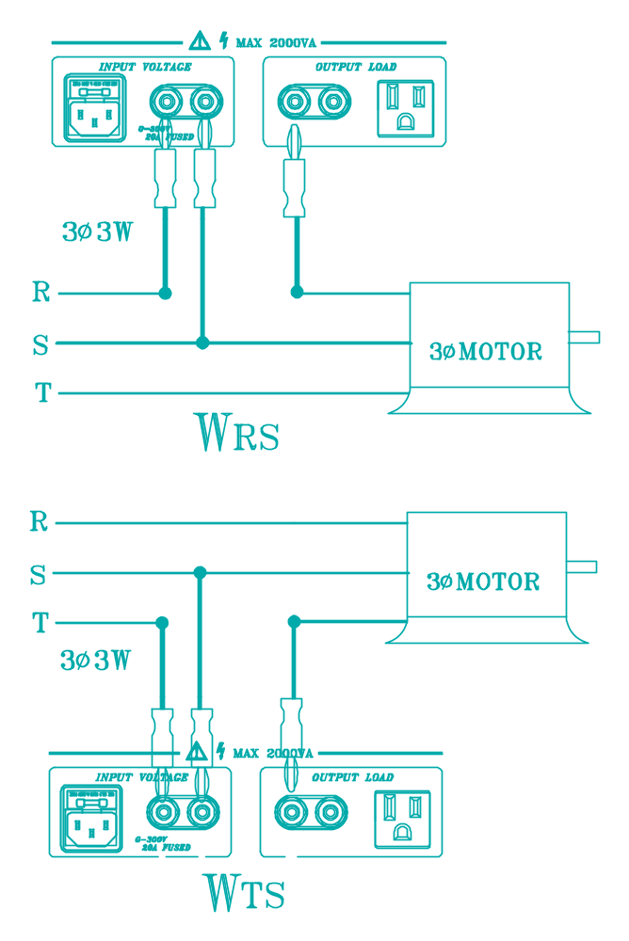

Measure WRS first(RST phases must be correctly identified)
1.Connect R-phase of the power source to the black terminal of input voltage
2.Connect S-phase of the power source to the red terminal of input voltage
3.Plug the R-phase of the device to be tested to the black terminal of the output load. Do not short R-phase of the device to be tested with the R-phase of the input power source.
4.Record the reading of WRS displayed on the W LCD.
Measure WTS secondly
(RST phases must be correctly identified)
5.Connect T-phase of the power source to the black terminal of input voltage
6.Connect S-phase of the power source to the red terminal of input voltage
7.Plug the T-phase of the device to be tested to the black terminal of the output load. Do not short T-phase of the device to be tested with the T-phase of the input power source.
8.Record the reading of WTS displayed on the Watt LCD.
Calculation of True Power

where
W3φ: True Power (3φ 3W )
WRS: Power of R phase with respect to S phase
WTS: Power of R phase with respect to S phase
VA3φ: Apparent Power (3φ 3W and Balanced Load )
VAR3φ: Reactive Power (3φ 3W and Balanced Load )
PF3φ: Power Factor (3φ 3W and Balanced Load )

9.2 Using Two Power Analyzers
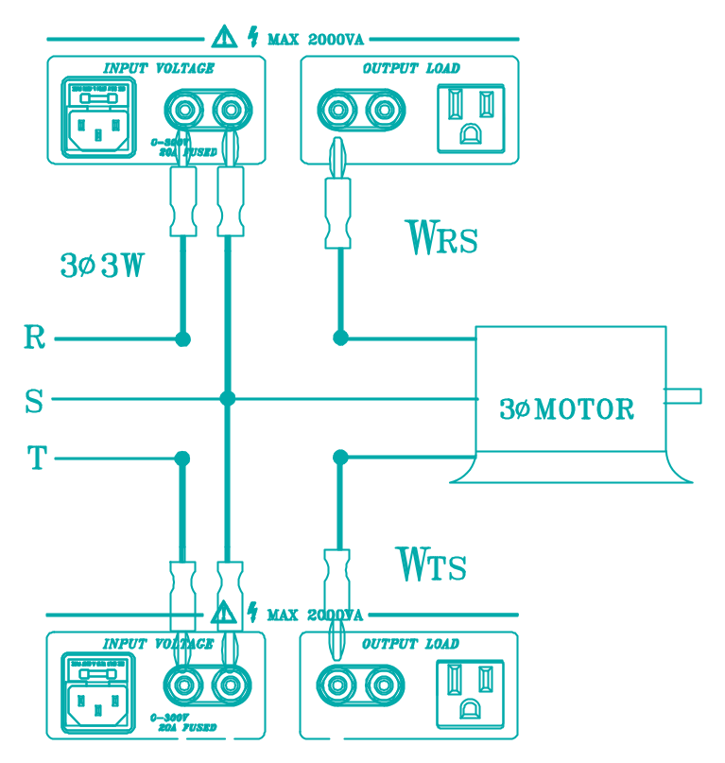

Measure WRS and WTS
(RST phases must be correctly identified)
1. Connect R-phase of the power source to the black terminal of input voltage of power analyzer 1.
2. Connect S-phase of the power source to the red terminal of input voltage of power analyzer 1.
3. Plug the R-phase of the device to be tested to the black terminal of the output load of power analyzer 1. Do not short R-phase of the load with the R-phase of the input power source.
4. Record the reading of WRS displayed on the W LCD of power analyzer 1.
5. Connect T-phase of the power source to the black terminal of input voltage of power analyzer 2.
6. Connect S-phase of the power source to the red terminal of input voltage of power analyzer 2.
7. Plug the T-phase of the device to be tested to the black terminal of the output load. Do not short T-phase of the device to be tested with the T-phase of the input power source.
8. Record the reading of WTS displayed on the Watt LCD of power analyzer 2.

Calculation of True Power

9.3 Using Conduct Through (CTs) and 2 Power Analyzers
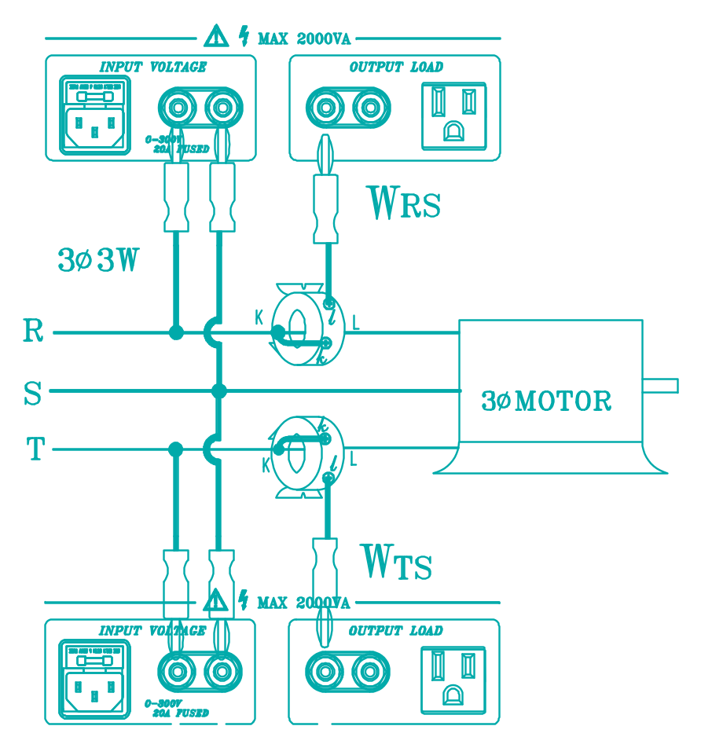

Measure WRS and WTS(RST phases must be correctly identified)
1. Connect R-phase to the black terminal of input voltage of power analyzer 1.
2. Connect S-phase to the red terminal of input voltage of power analyzer 1.
3. Connect k terminal of CT1 with R-phase.
4. Connect l terminal of CT1 with the black terminal of output load of power analyzer 1.
5. The Watt reading of power analyzer 1 is WRS
6. Connect T-phase to the black terminal of input voltage of power analyzer 2.
7. Connect S-phase to the red terminal of input voltage of power analyzer 2.
8. Connect k terminal of CT2 with R-phase.
9. Connect l terminal of CT2 with the black terminal of output load of power analyzer 1.
10. The Watt reading of power analyzer 2 is WTS.

Calculation of True Power

X. Trouble Shooting
10.1 If You Can Not Install the Software
Some users have encountered installation problem when using Windows 3.1 and Windows 3.11 with IBM Compatible 586-100MHz Hardware. There might be some I/O incompatibility problem with the floppy drive in that environment. To safely install the software, it is recommended that you install the software from hard disk instead of from floppy disk. To do that, please follow the following steps:
1. Change directory to root directory by typing:
cd \
2. Create a temporary directory by typing
md temp
3. Insert floppy disk into drive A and copy all the files from floppy disk to the temporary directory by typing
copy a:\*.* c:\temp\*.*
4. Start Microsoft Windows
5. From Program Manager, select FILE menu and choose RUN
6. Type in c:\temp\setup and press ENTER

If you are not able to execute SETUP program, or the program does not run properly, it is recommended that you reinstall WINDOWS 3.1 or 3.11.

10.2 If Voltage or Current Reading Shows Zero
If the voltage or current reading shows zero while the power chord and load are connected to power source, probably the fuse is burned down. Refer to section 8.3 to replace 20A fuse.

XI. Nomenclature
PC: Personal Computer
W: True Watt
PF: Power Factor
V: True RMS Voltage
A: True RMS Ampere
Phase Angle:
Phase angle is the time difference between V and A.
It is calculated by cos-1(PF)
VA: Apparent Power( V * A)
VAR: Reactive Power ( SQRT(VA2 - W2) )
IR: Equivalent current (through equivalent resistance)
Req: Equivalent resistance
IL: Equivalent current (through equivalent inductance)
XL: Equivalent impedance of equivalent inductance
Leq: Equivalent inductance
Angle: Phase angle if the voltage is a sine wave
CAP: Required capacitance
CR: Carriage Return
LF: Line Feed
EPS: Datalogger (WM-02) Memory Self-test
EPE: Erasing Datalogger Memory (WM-02)
W3φ: True Power (3φ, 3W )
WRS: Power of R phase with respect to S phase
WTS: Power of R phase with respect to S phase
VA3φ: Apparent Power (3φ, 3W and Balanced Load )
VAR3φ: Reactive Power (3φ, 3W and Balanced Load )
PF3φ: Power Factor (3φ, 3W and Balanced Load )
Mean: Mean Value
Std Dev: Standard Deviation
Best Fit: Draw a line to fit a curve with minimum error.

Note: Continuous Mode (Auto):

With this option selected, the user must specify an output time interval. Once configured, the user must turn datalogger power off and on to enable this function.

In this mode, the datalogger outputs data (W, A, V, PF + CR + LF) in ASCII format at the specified interval continuously.

4.3 Default RS-232C Settings

Baud Rate 9600
Stop bit 1
Data bits 8
Parity None

If users are writing their own applications, they must make sure the DTR must provide 10V (or higher), and the RTS must provide -10V (or lower). Voltage (10V, -10V) from DTR and RTS is used to generated RS-232C signal. DTR is usually enabled (10V). But RTS has to be disabled in order to be -10V. To do that in BASIC, adding RS parameter in the OPEN command:

OPEN "COM1: 9600, N, 8, 1, CS, DS, CD, RS" as #1

Refer to section 7.4 and 5.4.5 for details if users need to change the baud rate.

